Department of Information Technology

Semester: V Name of Student:
Academic Year: 2022-23 Student ID:
Class / Branch: TE IT
Subject: Security Lab (SL)
Name of Instructor: Prof. Apeksha Mohite

EXPERIMENT NO. 2
Aim: To Study use of access control Lists to deploy security policies of Web Access by configuring authentication based proxy server by using SQUID.

Verifying state of squid daemon and socket status after installation :
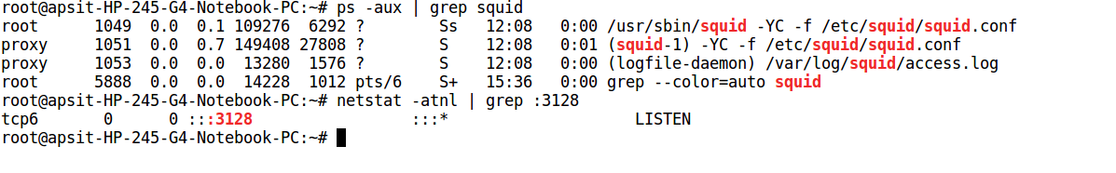
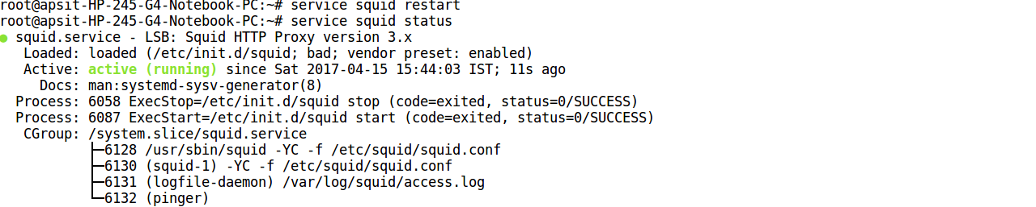

Squid Configuration file with required ACL directives and actions :
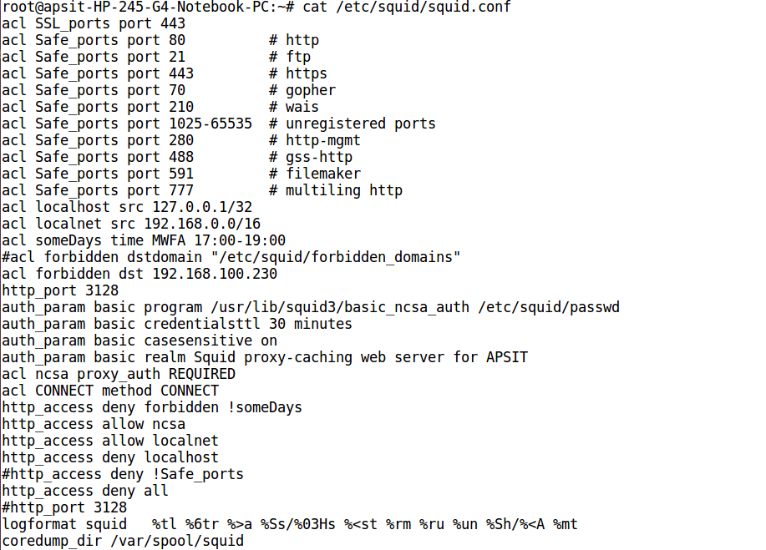
Log Analysis of Configured Proxy Server and verifying ACL directives working :
root@apsit-HP-245-G4-Notebook-PC:~# tail -f /var/log/squid/access.log
15/Apr/2017:15:51:48 +0530 155 192.168.3.140 TCP_MISS/200 3625 GET ftp://192.168.25.25/ kiran HIER_DIRECT/192.168.25.25 text/html
15/Apr/2017:15:52:52 +0530 88 192.168.3.140 TCP_MISS/200 14512 GET ftp://192.168.25.25/pub/ALInux/ kiran HIER_DIRECT/192.168.25.25 text/html
15/Apr/2017:15:59:09 +0530 0 192.168.3.140 TCP_DENIED/403 4177 GET http://192.168.100.230/favicon.ico - HIER_NONE/- text/html
15/Apr/2017:15:59:09 +0530 0 192.168.3.140 TCP_DENIED/403 4251 GET http://192.168.100.230/favicon.ico - HIER_NONE/- text/html

